Strict Mode

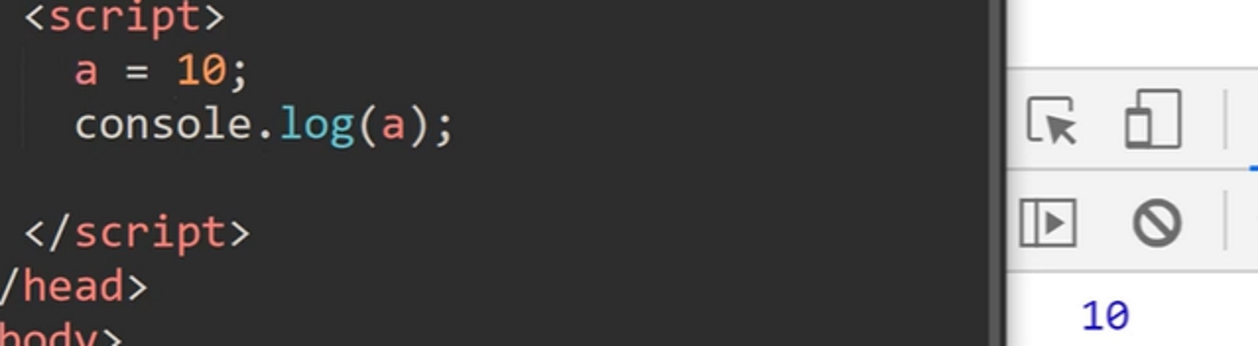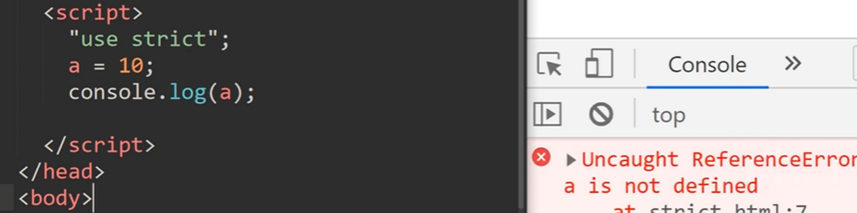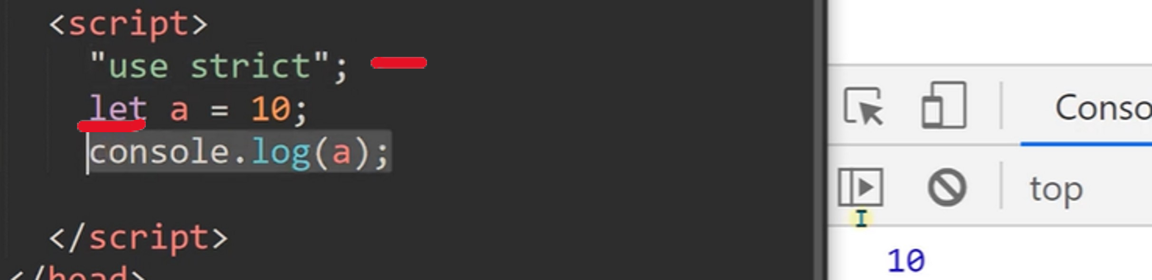

04 November 2023 13:44

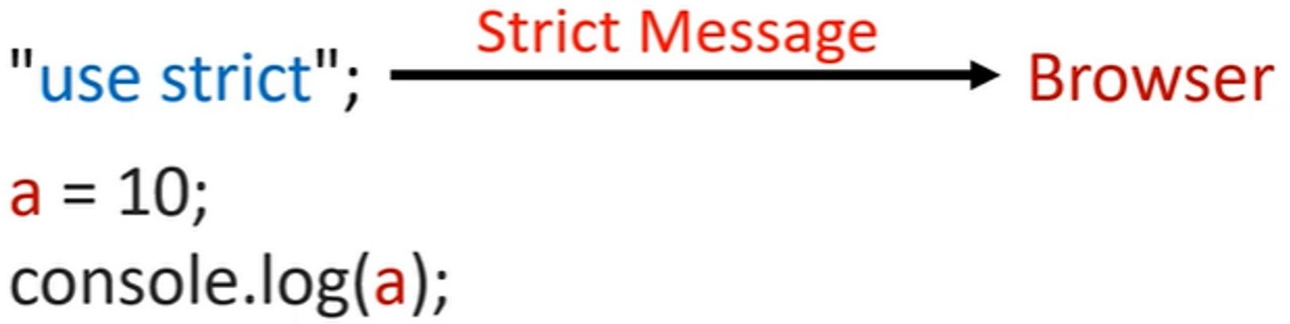Strict Mode

